CSCI 6441 – Homework 1

LAST NAME: FIRST NAME:

**Resources to be read and analyzed before you work in this homework assignment.**

1. Lecture Notes 01 to 03
2. Special attention must be given to the “Oracle Datamodeling” Notes Lessons 1 to 10. For your convenience the first 10 lessons of the Oracle data Modeler notes are posted with the Homework Assignment.
3. Oracle Data Modeling Practices Lessons 1 to 10 problem statement and solutions. Also attached to this Homework Assignment.

**Procedure to work in this assignment:**

1. Install the Oracle Datamodeler software in your workstation. The instructions are in **Appendix A**.
2. Review the Oracle Datamodeler concepts we discussed in class and summarized in the attached document “**DB_Modeling_and_RDB_Design_Lessons_1_to_10.pdf**”.
3. Read and document “**DB_Modeling_L1_to_L10_ACTIVITY_GUIDE.pdf**”.

The practices for lessons 1 to 5 deal with the **dataflow diagram** for the scenario “Starling DVD and Games Rentals” and the practices for Lessons 6 to 10 are to build the **ER diagram** for the database.

**Your Task: Use the Oracle Datamodeler software installed in your workstation to implement the practice exercises provided to you in** “**DB_Modeling_L1_to_L10_ACTIVITY_GUIDE.pdf**”**.**

**Objective: Become an expert in the utilization of the Oracle Datamodeler’s software to build Data Flow Diagrams and expressing the Database Conceptual Design using EER Diagrams.**

**Deliverables:**

**The solution must be provided in a single MS Word document.**

**In all the practices you must write down the Practice description and follow it with your solution.**

**All the DFDs and ERs must be built using the Oracle Data Modeler and the resulting diagrams must be copied to the MS document (Screen pictures).**

**Please do not submit separated documents.**

**Important: Please include a LEGEND in each diagram. The legend must contain your full name**

**Practices:**

Practice 1-1: Summarize in your own words the solution that is provided and evaluate the existing rental tracking database to determine whether it would be better to start with a new model or re-engineer the database that already exists.

Practice 2-1: Build the table given and indicate if you agree with then solution and why. You may also have your own solution.

Practice 3-1: Write a detailed explanation of the suggested solution. Insert into resulting diagrams into your MS Word document.

Practice 4.1: Follow the steps in Solution 4.1 to build the DFD

Practice 5.1: Summarize the concept of decomposition presented in Lesson 10. Follow the steps in Solution 5.1 to decompose the DFD.

Practice 6-1: Write a detailed explanation of the suggested solution. Insert into resulting diagrams into your MS Word document.

Practice 6.2: Write a detailed explanation of the suggested solution. Insert into resulting diagrams into your MS Word document.

Practice 7.1: Write a detailed explanation of the suggested solution. Insert into resulting diagrams into your MS Word document.

Practice 7.2: Write a detailed explanation of the suggested solution. Insert into resulting diagrams into your MS Word document.

Practice 8.1: Write a detailed explanation of the suggested solution. Insert into resulting diagrams into your MS Word document.

Practice 8.2: Write a detailed explanation of the suggested solution. Insert into resulting diagrams into your MS Word document.

Practice 9.1: Follow the steps in Solution 9.1 to build an Entity-Relationship Diagram (ERD)

Practice 10.1: Follow the steps in Solution 10.1 to complete the required ERD

**Appendix A**

**Installing the Oracle Datamodeler.**

Go to: [SQL Developer Datamodeler](http://www.oracle.com/technetwork/developer-tools/datamodeler/downloads/index.html)

<http://www.oracle.com/technetwork/developer-tools/datamodeler/downloads/index.html>

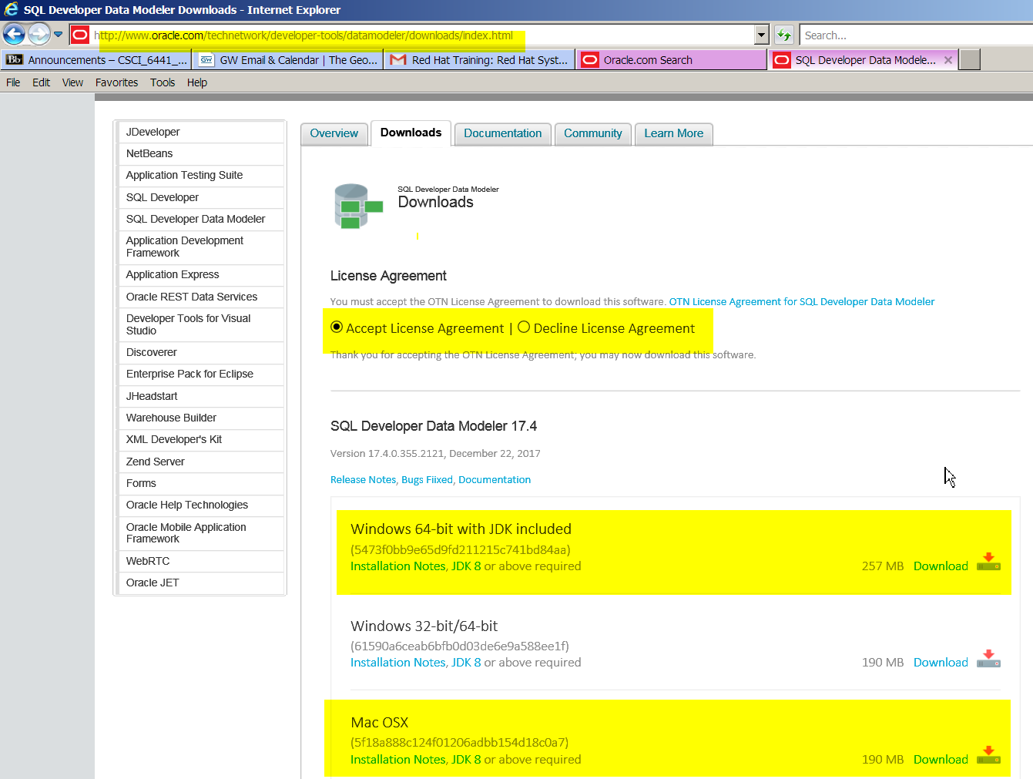

You will be prompted for your userid and password. If you do not have an Oracle userid, please create one. It is free.

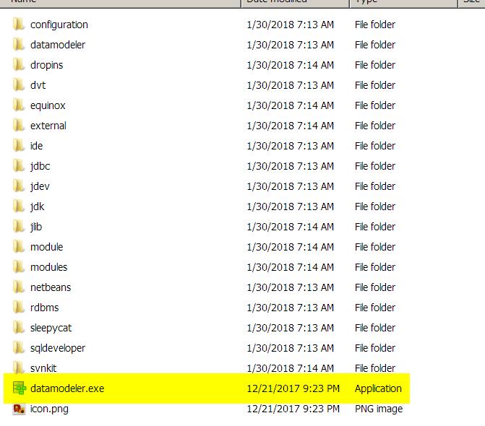

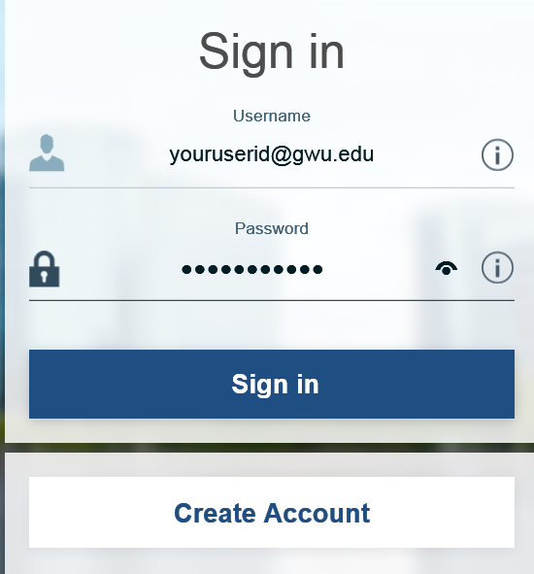

In Windows: A Zipped file will be downloaded

Unzip the file and the “datamodeler” directory will be created.

Double click on the “datamodeler.exe” to execute.